**“ E-COMMERCE SHOPPING MANAGEMENT SYSTEM ”**

### **A Project Submitted to the**

### **IT VEDANT Institute, Thane.**

**Data Science & Data Analytics With AI**



**SQL PROJECT**

**BY**

**HRUSHIKESH DHANAJI TAMBE**

Under the Guidance of

**Mr. Sameer Warsolkar**

**ABSTRACT**

The project involves the creation and management of a relational database for an e-commerce platform. The database comprises several interconnected tables, including Customer_Detail, Product_Detail, Order_details, and Sales_Detail. Customer_Detail records customer information, while Product_Detail captures details about the products and associates them with customers and orders. Order_details logs information about customer orders, including payment methods and order dates. Finally, Sales_Detail tracks the sales-related data, such as the amount, profit, and quantity of products associated with each order. The project demonstrates the organization of data in a structured manner, enabling effective retrieval and analysis of information related to customers, products, orders, and sales within the e-commerce system.

**ER – DIAGRAM (Entity Relation Diagram) :-**

Primary Keys :-

1. Customer_ID
2. Prod_ID
3. Order_id

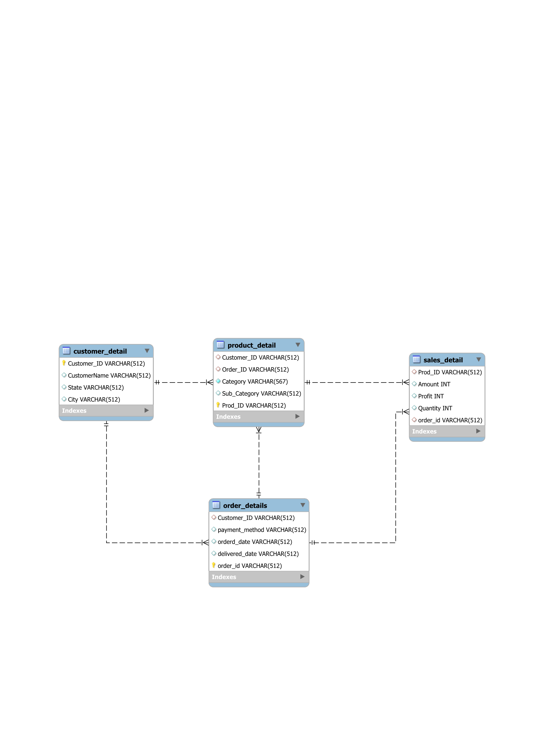

**Table Descriptions :-**

1. Customer_Detail

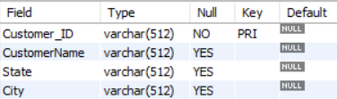

1. Product_Detail

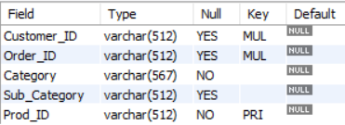

1. Order_details

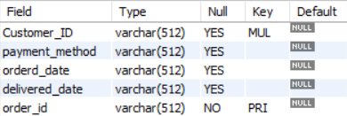

1. Sales_Detail

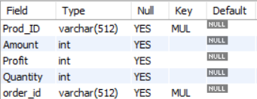

**COMMANDS :-**

**Creating Tables -**

**Create Table Customer_Detail :**

CREATE TABLE Customer_Detail (

Customer_ID VARCHAR(512) PRIMARY KEY,

CustomerName VARCHAR(512),

State VARCHAR(512),

City VARCHAR(512));

**Create Table Product_Detail :**

CREATE TABLE Product_Detail (

Customer_ID VARCHAR(512),

Order_ID VARCHAR(512),

Category VARCHAR(512),

Sub_Category VARCHAR(512),

Prod_ID VARCHAR(512) PRIMARY KEY,

FOREIGN KEY (Customer_ID) REFERENCES Customer_Detail(Customer_ID),

FOREIGN KEY (Order_ID) REFERENCES Order_details(Order_ID));

**Create Table Order_details**

CREATE TABLE Order_details (

Customer_ID VARCHAR(512),

payment_method VARCHAR(512),

orderd_date VARCHAR(512),

delivered_date VARCHAR(512),

order_id VARCHAR(512) PRIMARY KEY,

FOREIGN KEY (Customer_ID) REFERENCES Customer_Detail(Customer_ID));

**Create Table Sales_Detail**

CREATE TABLE Sales_Detail (

Prod_ID VARCHAR(512),

Amount INT,

Profit INT,

Quantity INT,

order_id VARCHAR(512),

FOREIGN KEY (order_id) REFERENCES Order_details(order_id),

FOREIGN KEY (Prod_ID) REFERENCES Product_Detail(Prod_ID));

**Populating Tables –**

**Populate Customer_Detail Table :-**

INSERT INTO Customer_Detail (Customer_ID, CustomerName, State, City) VALUES

('B-25601', 'Bharat', 'Gujarat', 'Ahmedabad'),

('B-25602', 'Pearl', 'Maharashtra', 'Pune'),

('B-25603', 'Jahan', 'Madhya Pradesh', 'Bhopal'),

('B-25604', 'Divsha', 'Rajasthan', 'Jaipur'),

('B-25605', 'Kasheen', 'West Bengal', 'Kolkata'),

('B-25606', 'Hazel', 'Karnataka', 'Bangalore'),

('B-25607', 'Sonakshi', 'Jammu and Kashmir', 'Kashmir'),

('B-25608', 'Aarushi', 'Tamil Nadu', 'Chennai'),

('B-25609', 'Jitesh', 'Uttar Pradesh', 'Lucknow'),

('B-25610', 'Yogesh', 'Bihar', 'Patna'),

('B-25611', 'Anita', 'Kerala ', 'Thiruvananthapuram'),

('B-25612', 'Shrichand', 'Punjab', 'Chandigarh'),

('B-25613', 'Mukesh', 'Haryana', 'Chandigarh'),

('B-25614', 'Vandana', 'Himachal Pradesh', 'Simla'),

('B-25615', 'Bhavna', 'Sikkim', 'Gangtok'),

('B-25616', 'Kanak', 'Goa', 'Goa'),

('B-25617', 'Sagar', 'Nagaland', 'Kohima'),

('B-25618', 'Manju', 'Andhra Pradesh', 'Hyderabad'),

('B-25619', 'Ramesh', 'Gujarat', 'Ahmedabad'),

('B-25620', 'Sarita', 'Maharashtra', 'Pune'),

('B-25621', 'Deepak', 'Madhya Pradesh', 'Bhopal'),

('B-25622', 'Monisha', 'Rajasthan', 'Jaipur'),

('B-25623', 'Atharv', 'West Bengal', 'Kolkata'),

('B-25624', 'Vini', 'Karnataka', 'Bangalore'),

('B-25625', 'Pinky', 'Jammu and Kashmir', 'Kashmir'),

('B-25626', 'Bhishm', 'Maharashtra', 'Mumbai'),

('B-25627', 'Hitika', 'Madhya Pradesh', 'Indore'),

('B-25628', 'Pooja', 'Bihar', 'Patna'),

('B-25629', 'Hemant', 'Kerala ', 'Thiruvananthapuram'),

('B-25630', 'Sahil', 'Punjab', 'Chandigarh'),

('B-25631', 'Ritu', 'Haryana', 'Chandigarh'),

('B-25632', 'Manish', 'Himachal Pradesh', 'Simla'),

('B-25633', 'Amit', 'Sikkim', 'Gangtok'),

('B-25634', 'Sanjay', 'Goa', 'Goa'),

('B-25635', 'Nidhi', 'Nagaland', 'Kohima'),

('B-25636', 'Nishi', 'Maharashtra', 'Mumbai'),

('B-25637', 'Ashmi', 'Madhya Pradesh', 'Indore'),

('B-25638', 'Parth', 'Maharashtra', 'Pune'),

('B-25639', 'Lisha', 'Madhya Pradesh', 'Bhopal'),

('B-25640', 'Paridhi', 'Rajasthan', 'Jaipur'),

('B-25641', 'Parishi', 'West Bengal', 'Kolkata'),

('B-25642', 'Ajay', 'Karnataka', 'Bangalore'),

('B-25643', 'Kirti', 'Jammu and Kashmir', 'Kashmir'),

('B-25644', 'Mayank', 'Maharashtra', 'Mumbai'),

('B-25645', 'Yaanvi', 'Madhya Pradesh', 'Indore'),

('B-25646', 'Sonal', 'Bihar', 'Patna'),

('B-25647', 'Sharda', 'Kerala ', 'Thiruvananthapuram'),

('B-25648', 'Aditya', 'Punjab', 'Chandigarh'),

('B-25649', 'Rachna', 'Haryana', 'Chandigarh'),

('B-25650', 'Chirag', 'Maharashtra', 'Mumbai'),

('B-25651', 'Anurag', 'Madhya Pradesh', 'Indore'),

('B-25652', 'Tushina', 'Goa', 'Goa'),

('B-25653', 'Farah', 'Nagaland', 'Kohima'),

('B-25654', 'Sabah', 'Maharashtra', 'Mumbai'),

('B-25655', 'Nida', 'Madhya Pradesh', 'Indore'),

('B-25656', 'Priyanka', 'Maharashtra', 'Pune'),

('B-25657', 'Tulika', 'Madhya Pradesh', 'Bhopal'),

('B-25658', 'Shefali', 'Rajasthan', 'Jaipur'),

('B-25659', 'Sanskriti', 'West Bengal', 'Kolkata'),

('B-25660', 'Shruti', 'Karnataka', 'Bangalore'),

('B-25661', 'Subhashree', 'Jammu and Kashmir', 'Kashmir'),

('B-25662', 'Sweta', 'Maharashtra', 'Mumbai'),

('B-25663', 'Pournamasi', 'Madhya Pradesh', 'Indore'),

('B-25664', 'Pratyusmita', 'Bihar', 'Patna'),

('B-25665', 'Chayanika', 'Kerala ', 'Thiruvananthapuram'),

('B-25666', 'Tanvi', 'Punjab', 'Chandigarh'),

('B-25667', 'Anjali', 'Haryana', 'Chandigarh'),

('B-25668', 'Rhea', 'Himachal Pradesh', 'Simla'),

('B-25669', 'Piyali', 'Sikkim', 'Gangtok'),

('B-25670', 'Charika', 'Goa', 'Goa'),

('B-25671', 'Mitali', 'Nagaland', 'Kohima'),

('B-25672', 'Akanksha', 'Andhra Pradesh', 'Hyderabad'),

('B-25673', 'Arsheen', 'Gujarat', 'Ahmedabad'),

('B-25674', 'Mahima', 'Maharashtra', 'Pune'),

('B-25675', 'Shreya', 'Madhya Pradesh', 'Bhopal'),

('B-25676', 'Chandni', 'Rajasthan', 'Jaipur'),

('B-25677', 'Ekta', 'West Bengal', 'Kolkata'),

('B-25678', 'Bathina', 'Karnataka', 'Bangalore'),

('B-25679', 'Avni', 'Maharashtra', 'Mumbai');

**Populate Product_Detail Table :-**

INSERT INTO Product_Detail (Customer_ID, Order_ID, Category, Sub_Category, Prod_ID) VALUES

('B-25601', 'O-10076', 'Furniture', 'Bookcases', 'P-1065'),

('B-25602', 'O-10071', 'Clothing', 'Stole', 'P-1075'),

('B-25603', 'O-10089', 'Clothing', 'Hankerchief', 'P-1001'),

('B-25604', 'O-10016', 'Electronics', 'Electronic Games', 'P-1032'),

('B-25605', 'O-10009', 'Electronics', 'Phones', 'P-1056'),

('B-25606', 'O-10011', 'Electronics', 'Phones', 'P-1064'),

('B-25607', 'O-10037', 'Electronics', 'Phones', 'P-1035'),

('B-25608', 'O-10087', 'Clothing', 'Saree', 'P-1016'),

('B-25609', 'O-10040', 'Clothing', 'Saree', 'P-1071'),

('B-25610', 'O-10081', 'Clothing', 'Trousers', 'P-1082'),

('B-25611', 'O-10074', 'Furniture', 'Chairs', 'P-1058'),

('B-25612', 'O-10008', 'Clothing', 'Saree', 'P-1044'),

('B-25613', 'O-10082', 'Clothing', 'Trousers', 'P-1061'),

('B-25614', 'O-10058', 'Clothing', 'Stole', 'P-1091'),

('B-25615', 'O-10038', 'Clothing', 'Stole', 'P-1073'),

('B-25616', 'O-10083', 'Clothing', 'Hankerchief', 'P-1004'),

('B-25617', 'O-10041', 'Clothing', 'Kurti', 'P-1067'),

('B-25618', 'O-10019', 'Clothing', 'T-shirt', 'P-1031'),

('B-25619', 'O-10055', 'Clothing', 'Saree', 'P-1026'),

('B-25620', 'O-10049', 'Clothing', 'Saree', 'P-1024'),

('B-25621', 'O-10092', 'Clothing', 'Shirt', 'P-1013'),

('B-25622', 'O-10057', 'Clothing', 'Leggings', 'P-1074'),

('B-25623', 'O-10023', 'Furniture', 'Tables', 'P-1038'),

('B-25624', 'O-10044', 'Furniture', 'Chairs', 'P-1060'),

('B-25625', 'O-10046', 'Clothing', 'Hankerchief', 'P-1047'),

('B-25626', 'O-10077', 'Electronics', 'Printers', 'P-1029'),

('B-25627', 'O-10025', 'Electronics', 'Electronic Games', 'P-1022'),

('B-25628', 'O-10060', 'Clothing', 'Saree', 'P-1079'),

('B-25629', 'O-10059', 'Electronics', 'Printers', 'P-1055'),

('B-25630', 'O-10062', 'Clothing', 'Stole', 'P-1023'),

('B-25631', 'O-10017', 'Electronics', 'Accessories', 'P-1069'),

('B-25632', 'O-10096', 'Electronics', 'Printers', 'P-1077'),

('B-25633', 'O-10053', 'Clothing', 'Saree', 'P-1063'),

('B-25634', 'O-10072', 'Furniture', 'Furnishings', 'P-1085'),

('B-25635', 'O-10002', 'Clothing', 'Saree', 'P-1095'),

('B-25636', 'O-10056', 'Furniture', 'Chairs', 'P-1012'),

('B-25637', 'O-10001', 'Clothing', 'Saree', 'P-1051'),

('B-25638', 'O-10042', 'Furniture', 'Bookcases', 'P-1049'),

('B-25639', 'O-10027', 'Electronics', 'Electronic Games', 'P-1007'),

('B-25640', 'O-10078', 'Clothing', 'Hankerchief', 'P-1045'),

('B-25641', 'O-10095', 'Clothing', 'Hankerchief', 'P-1028'),

('B-25642', 'O-10084', 'Clothing', 'Stole', 'P-1018'),

('B-25643', 'O-10005', 'Clothing', 'Hankerchief', 'P-1097'),

('B-25644', 'O-10061', 'Clothing', 'Hankerchief', 'P-1027'),

('B-25645', 'O-10045', 'Electronics', 'Electronic Games', 'P-1092'),

('B-25646', 'O-10033', 'Furniture', 'Bookcases', 'P-1036'),

('B-25647', 'O-10004', 'Clothing', 'Hankerchief', 'P-1042'),

('B-25648', 'O-10093', 'Clothing', 'Saree', 'P-1093'),

('B-25649', 'O-10073', 'Electronics', 'Printers', 'P-1039'),

('B-25650', 'O-10098', 'Electronics', 'Electronic Games', 'P-1033'),

('B-25651', 'O-10036', 'Electronics', 'Electronic Games', 'P-1072'),

('B-25652', 'O-10051', 'Electronics', 'Phones', 'P-1006'),

('B-25653', 'O-10054', 'Clothing', 'Saree', 'P-1089'),

('B-25654', 'O-10052', 'Clothing', 'Stole', 'P-1050'),

('B-25655', 'O-10091', 'Clothing', 'Stole', 'P-1057'),

('B-25656', 'O-10068', 'Clothing', 'Saree', 'P-1041'),

('B-25657', 'O-10020', 'Clothing', 'Stole', 'P-1009'),

('B-25658', 'O-10028', 'Clothing', 'Hankerchief', 'P-1054'),

('B-25659', 'O-10026', 'Clothing', 'Hankerchief', 'P-1019'),

('B-25660', 'O-10010', 'Clothing', 'Leggings', 'P-1083'),

('B-25661', 'O-10014', 'Clothing', 'Saree', 'P-1034'),

('B-25662', 'O-10064', 'Electronics', 'Phones', 'P-1053'),

('B-25663', 'O-10097', 'Furniture', 'Chairs', 'P-1017'),

('B-25664', 'O-10018', 'Clothing', 'Stole', 'P-1066'),

('B-25665', 'O-10067', 'Clothing', 'Skirt', 'P-1086'),

('B-25666', 'O-10034', 'Clothing', 'Saree', 'P-1025'),

('B-25667', 'O-10003', 'Furniture', 'Furnishings', 'P-1087'),

('B-25668', 'O-10024', 'Clothing', 'Trousers', 'P-1005'),

('B-25669', 'O-10039', 'Clothing', 'Stole', 'P-1010'),

('B-25670', 'O-10012', 'Clothing', 'Kurti', 'P-1099'),

('B-25671', 'O-10032', 'Electronics', 'Phones', 'P-1020'),

('B-25672', 'O-10022', 'Clothing', 'Stole', 'P-1008'),

('B-25673', 'O-10029', 'Clothing', 'T-shirt', 'P-1080'),

('B-25674', 'O-10099', 'Clothing', 'Kurti', 'P-1048'),

('B-25675', 'O-10086', 'Furniture', 'Furnishings', 'P-1030'),

('B-25676', 'O-10094', 'Clothing', 'Leggings', 'P-1015'),

('B-25677', 'O-10006', 'Electronics', 'Phones', 'P-1088'),

('B-25678', 'O-10047', 'Clothing', 'Saree', 'P-1090'),

('B-25679', 'O-10021', 'Clothing', 'Trousers', 'P-1014');

**Populate Order_details Table :-**

INSERT INTO Order_details (Customer_ID, payment_method, orderd_date, delivered_date, order_id) VALUES

('B-25601', 'EMI', '01-02-2019', '04-02-2019', 'O-10076'),

('B-25602', 'UPI', '01-09-2018', '11-09-2018', 'O-10071'),

('B-25603', 'EMI', '04-05-2018', '14-05-2018', 'O-10089'),

('B-25604', 'UPI', '18-12-2018', '24-12-2018', 'O-10016'),

('B-25605', 'EMI', '05-01-2019', '15-01-2019', 'O-10009'),

('B-25606', 'UPI', '09-10-2018', '15-10-2018', 'O-10011'),

('B-25607', 'UPI', '01-03-2019', '07-03-2019', 'O-10037'),

('B-25608', 'COD', '01-04-2018', '13-04-2018', 'O-10087'),

('B-25609', 'COD', '11-06-2018', '19-06-2018', 'O-10040'),

('B-25610', 'COD', '23-08-2018', '01-09-2018', 'O-10081'),

('B-25611', 'UPI', '01-02-2019', '02-02-2019', 'O-10074'),

('B-25612', 'EMI', '08-07-2018', '09-07-2018', 'O-10008'),

('B-25613', 'UPI', '21-07-2018', '22-07-2018', 'O-10082'),

('B-25614', 'EMI', '09-08-2018', '11-08-2018', 'O-10058'),

('B-25615', 'UPI', '17-12-2018', '25-12-2018', 'O-10038'),

('B-25616', 'UPI', '06-01-2019', '13-01-2019', 'O-10083'),

('B-25617', 'UPI', '01-05-2018', '03-05-2018', 'O-10041'),

('B-25618', 'COD', '02-11-2018', '13-11-2018', 'O-10019'),

('B-25619', 'UPI', '19-11-2018', '25-11-2018', 'O-10055'),

('B-25620', 'COD', '11-08-2018', '12-08-2018', 'O-10049'),

('B-25621', 'COD', '05-09-2018', '12-09-2018', 'O-10092'),

('B-25622', 'EMI', '18-09-2018', '20-09-2018', 'O-10057'),

('B-25623', 'COD', '01-01-2019', '06-01-2019', 'O-10023'),

('B-25624', 'EMI', '12-02-2019', '24-02-2019', 'O-10044'),

('B-25625', 'COD', '21-07-2018', '02-08-2018', 'O-10046'),

('B-25626', 'COD', '05-12-2018', '06-12-2018', 'O-10077'),

('B-25627', 'COD', '01-10-2018', '10-10-2018', 'O-10025'),

('B-25628', 'UPI', '10-06-2018', '20-06-2018', 'O-10060'),

('B-25629', 'UPI', '01-04-2018', '09-04-2018', 'O-10059'),

('B-25630', 'EMI', '01-03-2019', '14-03-2019', 'O-10062'),

('B-25631', 'UPI', '19-10-2018', '22-10-2018', 'O-10017'),

('B-25632', 'COD', '05-03-2019', '07-03-2019', 'O-10096'),

('B-25633', 'EMI', '01-05-2018', '13-05-2018', 'O-10053'),

('B-25634', 'EMI', '01-11-2018', '10-11-2018', 'O-10072'),

('B-25635', 'EMI', '01-06-2018', '09-06-2018', 'O-10002'),

('B-25636', 'EMI', '17-04-2018', '29-04-2018', 'O-10056'),

('B-25637', 'EMI', '01-02-2019', '12-02-2019', 'O-10001'),

('B-25638', 'COD', '01-09-2018', '11-09-2018', 'O-10042'),

('B-25639', 'EMI', '04-05-2018', '08-05-2018', 'O-10027'),

('B-25640', 'UPI', '18-12-2018', '31-12-2018', 'O-10078'),

('B-25641', 'EMI', '05-01-2019', '07-01-2019', 'O-10095'),

('B-25642', 'EMI', '09-10-2018', '19-10-2018', 'O-10084'),

('B-25643', 'COD', '01-03-2019', '06-03-2019', 'O-10005'),

('B-25644', 'UPI', '01-04-2018', '13-04-2018', 'O-10061'),

('B-25645', 'UPI', '11-06-2018', '19-06-2018', 'O-10045'),

('B-25646', 'UPI', '23-08-2018', '29-08-2018', 'O-10033'),

('B-25647', 'EMI', '01-02-2019', '14-02-2019', 'O-10004'),

('B-25648', 'EMI', '08-07-2018', '21-07-2018', 'O-10093'),

('B-25649', 'EMI', '21-07-2018', '31-07-2018', 'O-10073'),

('B-25650', 'EMI', '09-08-2018', '14-08-2018', 'O-10098'),

('B-25651', 'EMI', '17-12-2018', '26-12-2018', 'O-10036'),

('B-25652', 'UPI', '06-01-2019', '12-01-2019', 'O-10051'),

('B-25653', 'UPI', '01-05-2018', '13-05-2018', 'O-10054'),

('B-25654', 'EMI', '02-11-2018', '10-11-2018', 'O-10052'),

('B-25655', 'COD', '19-11-2018', '24-11-2018', 'O-10091'),

('B-25656', 'COD', '11-08-2018', '12-08-2018', 'O-10068'),

('B-25657', 'COD', '05-09-2018', '16-09-2018', 'O-10020'),

('B-25658', 'UPI', '18-09-2018', '19-09-2018', 'O-10028'),

('B-25659', 'COD', '01-01-2019', '12-01-2019', 'O-10026'),

('B-25660', 'EMI', '12-02-2019', '20-02-2019', 'O-10010'),

('B-25661', 'COD', '21-07-2018', '03-08-2018', 'O-10014'),

('B-25662', 'UPI', '05-12-2018', '13-12-2018', 'O-10064'),

('B-25663', 'UPI', '01-10-2018', '06-10-2018', 'O-10097'),

('B-25664', 'UPI', '10-06-2018', '19-06-2018', 'O-10018'),

('B-25665', 'COD', '01-04-2018', '06-04-2018', 'O-10067'),

('B-25666', 'UPI', '01-03-2019', '07-03-2019', 'O-10034'),

('B-25667', 'UPI', '19-10-2018', '30-10-2018', 'O-10003'),

('B-25668', 'COD', '05-03-2019', '10-03-2019', 'O-10024'),

('B-25669', 'EMI', '01-05-2018', '02-05-2018', 'O-10039'),

('B-25670', 'UPI', '01-11-2018', '10-11-2018', 'O-10012'),

('B-25671', 'COD', '01-06-2018', '07-06-2018', 'O-10032'),

('B-25672', 'UPI', '17-04-2018', '20-04-2018', 'O-10022'),

('B-25673', 'EMI', '01-02-2019', '05-02-2019', 'O-10029'),

('B-25674', 'COD', '01-09-2018', '04-09-2018', 'O-10099'),

('B-25675', 'UPI', '04-05-2018', '06-05-2018', 'O-10086'),

('B-25676', 'COD', '18-12-2018', '20-12-2018', 'O-10094'),

('B-25677', 'COD', '05-01-2019', '13-01-2019', 'O-10006'),

('B-25678', 'EMI', '09-10-2018', '20-10-2018', 'O-10047'),

('B-25679', 'COD', '01-03-2019', '06-03-2019', 'O-10021');

**Populate Sales_Detail Table :-**

INSERT INTO Sales_Detail (Prod_ID, Amount, Profit, Quantity, order_id) VALUES

('P-1065', '1275', '-1148', '7', 'O-10076'),

('P-1075', '66', '-12', '5', 'O-10071'),

('P-1001', '8', '-2', '3', 'O-10089'),

('P-1032', '80', '-56', '4', 'O-10016'),

('P-1056', '168', '-111', '2', 'O-10009'),

('P-1064', '424', '-272', '5', 'O-10011'),

('P-1035', '2617', '1151', '4', 'O-10037'),

('P-1016', '561', '212', '3', 'O-10087'),

('P-1071', '119', '-5', '8', 'O-10040'),

('P-1082', '1355', '-60', '5', 'O-10081'),

('P-1058', '24', '-30', '1', 'O-10074'),

('P-1044', '193', '-166', '3', 'O-10008'),

('P-1061', '180', '5', '3', 'O-10082'),

('P-1091', '116', '16', '4', 'O-10058'),

('P-1073', '107', '36', '6', 'O-10038'),

('P-1004', '12', '1', '2', 'O-10083'),

('P-1067', '38', '18', '1', 'O-10041'),

('P-1031', '65', '17', '2', 'O-10019'),

('P-1026', '157', '5', '9', 'O-10055'),

('P-1024', '75', '0', '7', 'O-10049'),

('P-1013', '87', '4', '2', 'O-10092'),

('P-1074', '50', '15', '4', 'O-10057'),

('P-1038', '1364', '-1864', '5', 'O-10023'),

('P-1060', '476', '0', '3', 'O-10044'),

('P-1047', '257', '23', '5', 'O-10046'),

('P-1029', '856', '385', '6', 'O-10077'),

('P-1022', '485', '29', '4', 'O-10025'),

('P-1079', '25', '-5', '4', 'O-10060'),

('P-1055', '1076', '-38', '4', 'O-10059'),

('P-1023', '107', '-54', '4', 'O-10062'),

('P-1069', '68', '-55', '5', 'O-10017'),

('P-1077', '781', '-594', '6', 'O-10096'),

('P-1063', '43', '0', '3', 'O-10053'),

('P-1085', '30', '-5', '2', 'O-10072'),

('P-1095', '160', '-59', '2', 'O-10002'),

('P-1012', '259', '-55', '2', 'O-10056'),

('P-1051', '1603', '0', '9', 'O-10001'),

('P-1049', '494', '54', '4', 'O-10042'),

('P-1007', '98', '-12', '2', 'O-10027'),

('P-1045', '68', '20', '5', 'O-10078'),

('P-1028', '42', '12', '5', 'O-10095'),

('P-1018', '116', '-56', '5', 'O-10084'),

('P-1097', '22', '-2', '3', 'O-10005'),

('P-1027', '14', '-2', '3', 'O-10061'),

('P-1092', '305', '-270', '5', 'O-10045'),

('P-1036', '362', '127', '1', 'O-10033'),

('P-1042', '12', '0', '2', 'O-10004'),

('P-1093', '353', '90', '8', 'O-10093'),

('P-1039', '193', '46', '1', 'O-10073'),

('P-1033', '233', '-10', '5', 'O-10098'),

('P-1072', '228', '63', '3', 'O-10036'),

('P-1006', '333', '-15', '3', 'O-10051'),

('P-1089', '534', '0', '3', 'O-10054'),

('P-1050', '53', '1', '4', 'O-10052'),

('P-1057', '158', '69', '3', 'O-10091'),

('P-1041', '149', '-87', '4', 'O-10068'),

('P-1009', '105', '20', '2', 'O-10020'),

('P-1054', '26', '12', '3', 'O-10028'),

('P-1019', '97', '29', '2', 'O-10026'),

('P-1083', '59', '30', '3', 'O-10010'),

('P-1034', '635', '-349', '5', 'O-10014'),

('P-1053', '46', '-14', '1', 'O-10064'),

('P-1017', '1103', '-276', '3', 'O-10097'),

('P-1066', '55', '-39', '4', 'O-10018'),

('P-1086', '45', '13', '4', 'O-10067'),

('P-1025', '24', '-9', '4', 'O-10034'),

('P-1087', '35', '-8', '2', 'O-10003'),

('P-1005', '1560', '421', '3', 'O-10024'),

('P-1010', '133', '12', '5', 'O-10039'),

('P-1099', '114', '-39', '5', 'O-10012'),

('P-1020', '143', '-129', '2', 'O-10032'),

('P-1008', '40', '-7', '3', 'O-10022'),

('P-1080', '34', '-22', '4', 'O-10029'),

('P-1048', '42', '-26', '2', 'O-10099'),

('P-1030', '89', '-89', '2', 'O-10086'),

('P-1015', '19', '-2', '2', 'O-10094'),

('P-1088', '249', '-130', '4', 'O-10006'),

('P-1090', '711', '-8', '4', 'O-10047'),

('P-1014', '496', '-79', '2', 'O-10021');

**JOIN QUERIES :-**

1. Show the Sub_Category and their total sales amount for a specific date.

select distinct Sub_Category,sum(Amount),orderd_date

from Product_Detail

JOIN Sales_Detail on Product_Detail.Prod_ID=Sales_Detail.Prod_ID

JOIN Order_details on Order_details.order_id=Sales_Detail.order_id

where orderd_date = '05-01-2019'

group by Sub_Category;

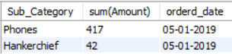

1. Display the customer names who have made more than FIVE purchases.

select Customer_Detail.Customer_ID,CustomerName, Quantity

from Customer_Detail

JOIN Product_Detail on Customer_Detail.Customer_ID=Product_Detail.Customer_ID

JOIN Sales_Detail on Product_Detail.Prod_ID=Sales_Detail.Prod_ID

where Quantity>5;

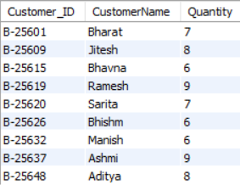

1. List the products that have been ordered by more than one customer, along with the customer names who ordered them.

SELECT PD.Sub_Category, COUNT(DISTINCT CD.Customer_ID) AS NumCustomers, GROUP_CONCAT(CD.CustomerName) AS CustomerNames

FROM Product_Detail PD

JOIN Sales_Detail SD ON PD.Prod_ID = SD.Prod_ID

JOIN Order_details OD ON SD.order_id = OD.order_id

JOIN Customer_Detail CD ON OD.Customer_ID = CD.Customer_ID

GROUP BY PD.Sub_Category

HAVING NumCustomers > 1 order by NumCustomers ASC;

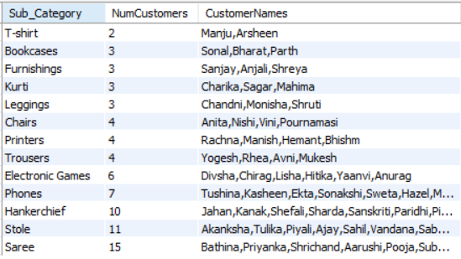

1. List total profit and total sales with customer ID for Mumbai city

SELECT CD.Customer_ID,

CD.CustomerName,

CD.City,

SUM(SD.Amount) AS TotalSales,

SUM(SD.Profit) AS TotalProfit

FROM Customer_Detail CD

JOIN Product_Detail PD ON CD.Customer_ID = PD.Customer_ID

JOIN Order_details OD ON PD.Order_ID = OD.order_id

JOIN Sales_Detail SD ON PD.Prod_ID = SD.Prod_ID AND PD.Order_ID = SD.order_id

WHERE CD.City = 'Mumbai'

GROUP BY CD.Customer_ID, CD.CustomerName, CD.City

ORDER BY CustomerName ASC;

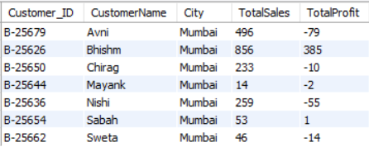

**SubQueries :-**

1. Retrieve the order IDs for orders placed by a specific customer.

SELECT * FROM Order_details

WHERE customer_id = (SELECT customer_id FROM Customer_Detail WHERE CustomerName = 'Pearl');

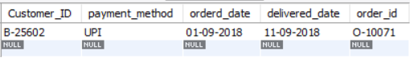

1. Retrieve the product details for orders placed in a specific cities.

SELECT *

FROM Product_Detail

WHERE Order_ID IN (SELECT Order_ID FROM Order_Details WHERE Customer_ID IN (SELECT Customer_ID FROM Customer_Detail WHERE City = 'Pune' or City='Jaipur'));

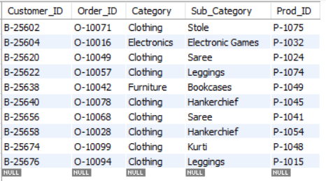

1. Find orders where the quantity sold is greater than the average quantity sold.

SELECT *

FROM Sales_Detail

WHERE Quantity > (SELECT AVG(Quantity) FROM Sales_Detail);

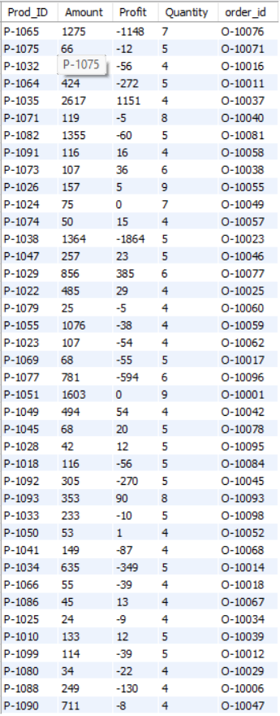

1. Get the total quantity sold for a specific category.

SELECT SUM(Quantity)

FROM Sales_Detail

WHERE Prod_ID IN (SELECT Prod_ID FROM Product_Detail WHERE Category = 'Electronics');



1. Retrieve orders with the highest sales amount.

SELECT *

FROM Sales_Detail

WHERE Amount = (SELECT MAX(Amount) FROM Sales_Detail);



**OTHER QUERIES :-**

1. Calculate the total number of orders placed using each payment method.

SELECT payment_method, COUNT(Order_ID) AS OrderCount

FROM Order_details

GROUP BY payment_method;

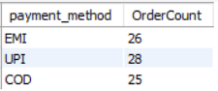

1. Retrieve the orders with the highest total sales amount.

SELECT Order_ID, SUM(Amount) AS TotalSales

FROM Sales_Detail

GROUP BY Order_ID

ORDER BY TotalSales DESC

LIMIT 1;



1. List the products with their corresponding categories and sub-categories.

SELECT Prod_ID, Category, Sub_Category

FROM Product_Detail

where Category="Furniture" AND Sub_Category="Chairs";

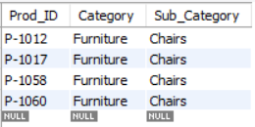

1. Retrieve the products in the 'Electronics' category.

SELECT *

FROM Product_Detail

WHERE Category = 'Electronics';

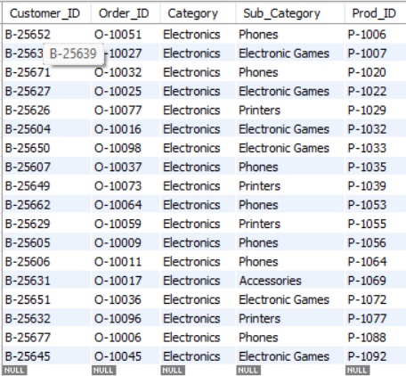

1. Find the average profit per order.

SELECT

AVG(Profit) AS AverageProfit_or_loss

FROM

Sales_Detail;



1. List Customers from Maharashtra

select Customer_ID, CustomerName, State

from Customer_Detail

where State = 'Maharashtra';

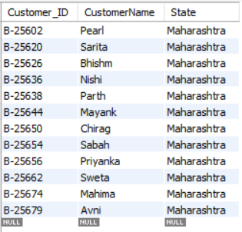

1. Change row consrtraints to not null

alter table Product_Detail

modify Category varchar(567) not null;

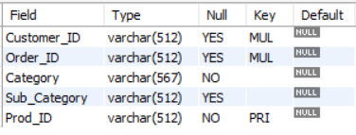

1. Update state where specific customer_id

update Customer_Detail

set state= "Raigad" where Customer_ID='B-25606'; 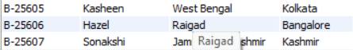

1. Show amount of product more than 400

select * from Sales_Detail

where Amount > 400;

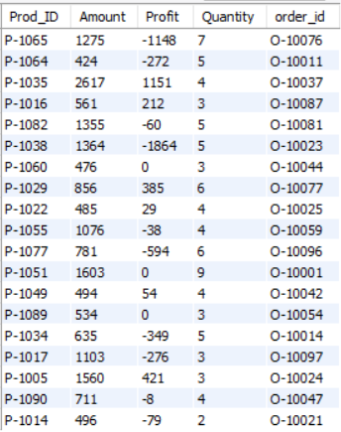

10) Show details where customer name is ending with "n"

select * from Customer_Detail where CustomerName like "%n";

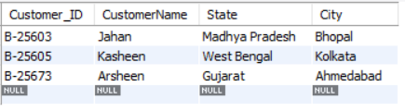

11) Show details where profit is not negative and quantity more than 5

select * from Sales_Detail

where Profit >=0 and Quantity < 5;

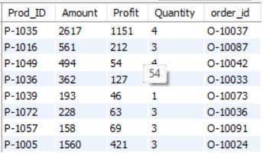

12) How many Customers Buy Phones on UPI

select * from Order_details

join Product_Detail on Order_details.Order_ID=Product_Detail.Order_ID

where Payment_Method = "UPI" and Sub_Category="Phones";

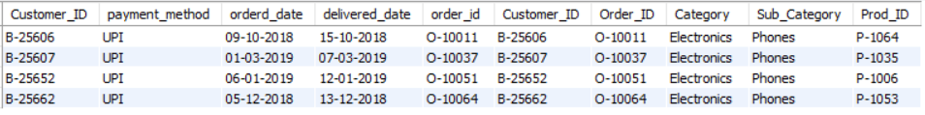

13) List top 5 max paid amount

SELECT Prod_ID, Max(Amount) as TOP_PAY FROM Sales_Detail

GROUP BY Prod_ID

ORDER BY TOP_PAY DESC limit 5;

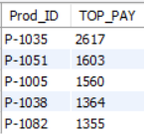

14) find Minimum profit in Negative with number of Quantities

SELECT Quantity, MIN(Profit) as MIN_P

FROM Sales_Detail

GROUP BY Quantity

HAVING MIN_P < 0

order by MIN_P DESC;

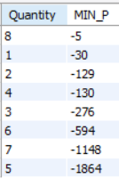

**CONCLUSION :-**

Project successfully demonstrates the design and implementation of a relational database system for managing customer information, product details, order processing, and sales records. The structured schema and relationships between tables facilitate efficient data retrieval and maintain data integrity. This database can serve as a foundation for further development, incorporating additional features such as analytics, reporting, and scalability to meet the evolving needs of the business. As businesses grow, a robust database management system becomes increasingly vital for streamlining operations, optimizing decision-making processes, and enhancing overall efficiency.

**THANK YOU**